**Chapter No.1**

**Introduction**

In the ever-evolving landscape of education, the efficient management of student records is crucial for the smooth operation of educational institutions. The Student Record Management System (SRMS) is a project conceived to address the growing complexities associated with student data handling in colleges, and universities. This project aims to revolutionize the traditional paper-based record-keeping methods and manual administrative tasks by introducing a robust and user-friendly digital solution.

Modern educational institutions face a myriad of challenges, from managing student enrollments and tracking attendance to grading assignments and maintaining comprehensive student profiles. These challenges demand a systematic and technologically advanced approach to ensure data accuracy, security, and accessibility. It seeks to provide a comprehensive solution to these challenges, offering an efficient, scalable, and adaptable system tailored to meet the unique needs of educational institutions.

**Chapter No.2**

**Literature Survey**

**2.1 Study of existing system / Review of research paper**

**2.1.1 Study of existing system**

* Manual Record-Keeping: Many educational institutions still rely on manual methods, including paper-based files and spreadsheets, for student record management. These systems are prone to errors, data loss, and inefficiency, making them less suitable for modern educational needs.
* Legacy Software: Some institutions use outdated, legacy software for record management. These systems may lack scalability, user-friendliness, and advanced features required for efficient student data management.
* Commercial Student Information Systems (SIS): Larger institutions often use commercial SIS software that provides a wide range of features for student record management. However, these systems can be expensive, complex to implement, and may not be easily customizable to specific institutional needs.
* Open Source Solutions: Some institutions turn to open-source SAPMS solutions to reduce costs and gain more control over customization. These systems may provide more flexibility but may require technical expertise for setup and maintenance.

**2.1.2 Review of research paper**

* "Enhancing Student Record Management in Higher Education Institutions": This paper may discuss the challenges faced by higher education institutions in managing student records and propose solutions or recommendations for improvement.
* "Adopting Cloud-Based Solutions for Student Academic Progress Management System ": Research on cloud-based solutions for SAPMS can shed light on the benefits of cloud technology in terms of data accessibility, security, and scalability.
* "Data Security and Privacy in Student Academic Progress Management System ": With increasing concerns about data security and privacy, this paper may explore the best practices and challenges in securing student records.
* "User-Centric Design in Student Academic Progress Management System ": Research focusing on user experience and interface design can provide insights into creating an intuitive and user-friendly SAPMS.
* "Analytics and Decision Support in Student Academic Progress Management System ": Papers on data analytics and decision support systems in education can highlight the importance of data-driven decision-making and its integration into SAPMS.
* "Integration of Mobile Technology in Student Academic Progress Management System ": Given the prevalence of mobile devices, research on mobile applications for SAPMS can be valuable.
* "Customization and Adaptation of SAPMS in Different Educational Settings": Research exploring how SAPMS can be adapted to various educational levels (e.g., K-12, higher education) and contexts can offer valuable insights.

**2.2 Limitations of existing system / Problems discussed in research papers**

**2.2.1 Limitations of existing system**

* Data Redundancy and Inconsistency: Existing systems often suffer from data redundancy and inconsistency due to the use of multiple databases or manual data entry, leading to inaccuracies and confusion.
* Limited Accessibility: Traditional systems may lack remote accessibility, making it challenging for stakeholders to access student records when needed, especially in remote or online learning environments.
* Inefficient Data Retrieval: Retrieving specific information from large datasets can be time-consuming and challenging in legacy systems, impacting the efficiency of administrative tasks.
* Security Concerns: Data security is a significant concern, with existing systems being vulnerable to breaches, unauthorized access, and data loss.
* Lack of Customization: Many existing systems are rigid and not easily customizable to meet the unique needs of different educational institutions.
* Scalability Issues: Some systems struggle to scale with growing institutions, causing performance issues and hindering future expansion.

**2.2.2 Problems discussed in research papers**

* Data Privacy and Compliance: Research papers often highlight concerns related to data privacy regulations, such as GDPR or FERPA, and discuss how SAPMS should comply with these regulations to protect students' sensitive information.
* Integration Challenges: Papers discuss the difficulties in integrating SAPMS with other educational software and systems, such as learning management systems (LMS) and financial systems, to ensure smooth data flow.
* User Training and Adoption: The adoption of SAPMS may face resistance, and research explores strategies to train and familiarize users with the system effectively.
* Data Analytics and Reporting: Research emphasizes the importance of advanced data analytics and reporting features in SAPMS for informed decision-making by administrators and educators.
* Mobile Accessibility: Papers discuss the need for mobile-friendly SAPMS solutions to accommodate the increasing use of mobile devices in education.
* User Experience (UX) Design: UX design and user-centered approaches are essential to ensure that SRMS is user-friendly and meets the needs of various stakeholders.
* Cost Considerations: Research often delves into the cost implications of implementing and maintaining an SAPMS, including initial setup costs, licensing fees, and ongoing maintenance expenses.
* Scalability and Performance: Scalability challenges are discussed, particularly in large institutions where the system must handle a high volume of data and users simultaneously.
* Backup and Disaster Recovery: Research highlights the importance of robust backup and disaster recovery mechanisms to prevent data loss.
* Vendor Lock-In: Papers caution against vendor lock-in when using commercial SAPMS solutions and explore alternatives like open-source systems

**2.3 Problem Identification / Need of a system**

* **Data Inefficiency and Errors:**
* Problem: Existing manual record-keeping methods are error-prone and time-consuming. Data redundancies and inconsistencies can lead to inaccuracies in student records.
* Need: An SRMS is needed to streamline data entry, reduce errors, and ensure data accuracy.
* **Limited Accessibility:**
* Problem: In traditional systems, student records may not be easily accessible remotely, hindering efficient administrative and educational processes, especially in online or remote learning environments.
* Need: An SRMS should provide secure, remote access to student records, facilitating efficient information retrieval from anywhere.
* **Data Security Concerns:**
* Problem: Existing systems may lack robust security measures, leaving student data vulnerable to breaches, unauthorized access, or loss.
* Need: An SRMS should prioritize data security, implementing encryption, access controls, and backup mechanisms to protect sensitive information.
* **Inefficient Data Retrieval:**
* Problem: Traditional systems may struggle with retrieving specific information from large datasets, leading to delays in administrative tasks.
* Need: An SRMS should offer efficient search and retrieval capabilities to save time and improve productivity.
* **Lack of Customization:**
* Problem: Many existing systems are rigid and do not allow for easy customization to meet the unique needs of different educational institutions.
* Need: An SRMS should be customizable, allowing institutions to adapt it to their specific requirements.
* **Scalability Challenges:**
* Problem: Some systems do not scale well with the growth of educational institutions, leading to performance issues and constraints.
* Need: An SRMS should be designed to scale smoothly as an institution expands to accommodate growing data and user needs.
* **Data Privacy Compliance:**
* Problem: Educational institutions must adhere to data privacy regulations (e.g., GDPR, FERPA), which can be challenging without appropriate data management tools.
* Need: An SRMS should ensure compliance with data privacy regulations, helping institutions avoid legal and reputational risks.
* **Integration Complexity:**
* Problem: Integrating SRMS with other educational software systems, such as Learning Management Systems (LMS) or financial systems, can be complex and time-consuming.
* Need: An SRMS should offer seamless integration capabilities to facilitate data flow between different systems.
* **Reporting and Analytics:**
* Problem: Existing systems may lack advanced reporting and analytics features, limiting data-driven decision-making.
* Need: An SRMS should provide robust reporting tools to extract insights and support informed decisions by administrators and educators.
* **User Training and Adoption:**
* Problem: Users may resist adopting a new system without effective training and user-friendly interfaces.
* Need: An SRMS should prioritize user training and offer a user-centric design to ensure widespread adoption.
* **Mobile Accessibility:**
* Problem: With the increasing use of mobile devices in education, existing systems may not be optimized for mobile access.
* Need: An SRMS should be mobile-friendly to cater to users who rely on smartphones and tablets.

**2.4 Problem definition**

* In educational institutions, the management of student records is currently plagued by inefficiencies, errors, and data security concerns due to reliance on manual record-keeping methods and outdated systems. These challenges hinder the institution's ability to provide accurate, accessible, and secure student data, impacting administrative tasks, decision-making processes, and the overall quality of education. The key problem areas include data inefficiency and errors resulting from manual processes, limited accessibility to student records, data security concerns, inefficient data retrieval methods, inflexibility in customization, and scalability challenges.
* The objective of the SRMS microproject is to design, develop, and implement a comprehensive Student Record Management System that addresses these identified problems. The system aims to streamline data management, enhance accessibility, ensure data security, improve efficiency, allow for customization, and support scalability while complying with data privacy regulations. The project's scope encompasses the design and development of the system, user training, and data migration from existing systems to the new SRMS. The expected outcomes include a modern and efficient SRMS tailored to the specific needs of the educational institution, eliminating data inefficiencies, improving accessibility, enhancing data security, enabling efficient data retrieval, allowing for customization, and supporting future scalability. Ultimately, the SRMS will contribute to better administrative processes, data-driven decision-making, and improved educational outcomes within the institution.

**Chapter No.3**

**Specifications**

**3.1 User Requirements**

**HOD:**

1. Notice Alert (Holiday notice / Event notice / Important Notice)

**Teacher:**

1. Teachers Remark
2. Extra Lecture Notice and Attendance

**Student:**

1. View:

* Attendance (Number of Lectures Attended)
* Submissions (Assignments and Practical)
* Syllabus
* Timetable
* Class Test Marks (1st and 2nd)

1. Feedback of teachers teaching and facilities provided to them
2. Submission Report (No dues)
3. Notes shared by teachers
4. Letter to HOD for personal or emergency reasons
5. Overall Report:

* Total percentage of attendance
* Marks obtained by student in Class Test 1 and 2
* Submissions Report (No dues, Assignment, Practical)
* Teachers Remark

**3.2 System Requirements**

**Mobile**

* Operating System: Android 9 or greater
* RAM: 2 GB

**PC**

* Operating System: Windows/Linux
* RAM: 2 GB
* Processor: Intel Core i3

**Chapter No.4**

**Proposed Methodology**

**4.1 Proposed work**

In this project, our objective is to create a comprehensive Student Academic Progress Management System customized to the unique needs of our educational institution. We'll start by defining the project's scope, assembling a project team, and conducting detailed requirements gathering and analysis, collaborating closely with administrators, educators, and IT personnel. Once the system requirements are clear, we'll move on to system design, focusing on efficient data storage, retrieval, and user-friendly interfaces.

The development phase will encompass building core SAPMS features, including user authentication, enrollment management, attendance tracking, grading, and reporting, while also implementing robust data security measures. Customization options will be developed to ensure adaptability to our institution's specific needs, and the system will be designed to scale efficiently to accommodate future growth in data and users.

Data migration from existing systems will be a critical task, requiring meticulous planning and verification to ensure data accuracy and completeness. Rigorous testing, including functional, integration, and security testing, will be conducted to identify and resolve any issues before user acceptance testing (UAT). To ensure a smooth transition, we'll provide comprehensive user training and develop system documentation.

Deployment will be executed in a controlled manner, with ongoing monitoring of system performance and immediate issue resolution. Maintaining the system's integrity and security is crucial, and an ongoing maintenance plan will be established to address updates, bug fixes, and enhancements, while continuous user support will be provided.

Compliance with data privacy regulations, such as GDPR or FERPA, will be a top priority, with stringent measures in place to protect student data. Regular audits and updates of data privacy policies and procedures will be conducted to ensure ongoing compliance.

Ultimately, the SAPMS microproject aims to deliver a modern, efficient, and secure Student Record Management System that enhances administrative processes, supports data-driven decision-making, and contributes to improved educational outcomes for our institution

* **Student Model Design (Flow)**

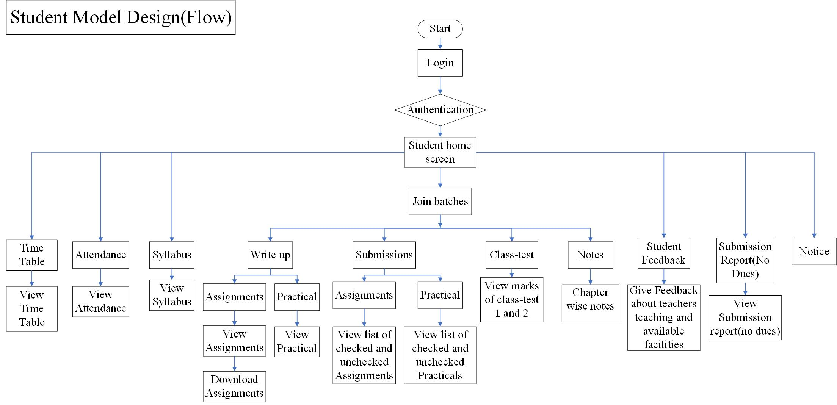

* **Attendance Database Design**

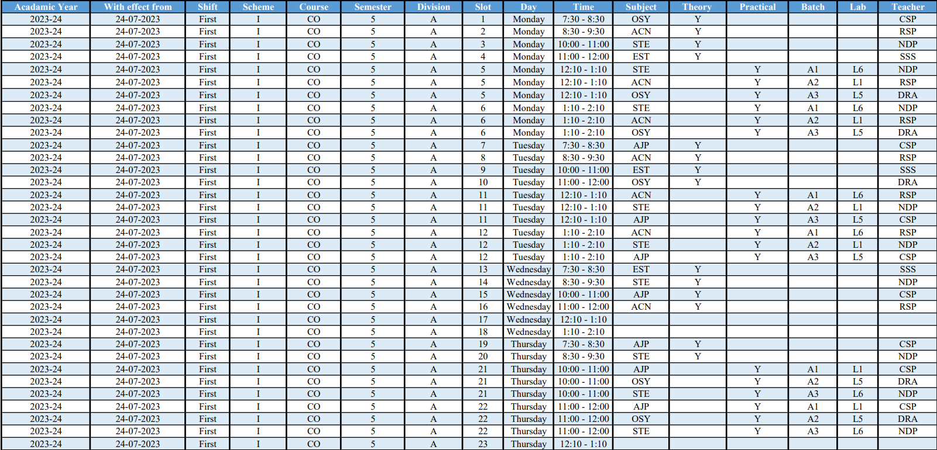

* **Students Flow**

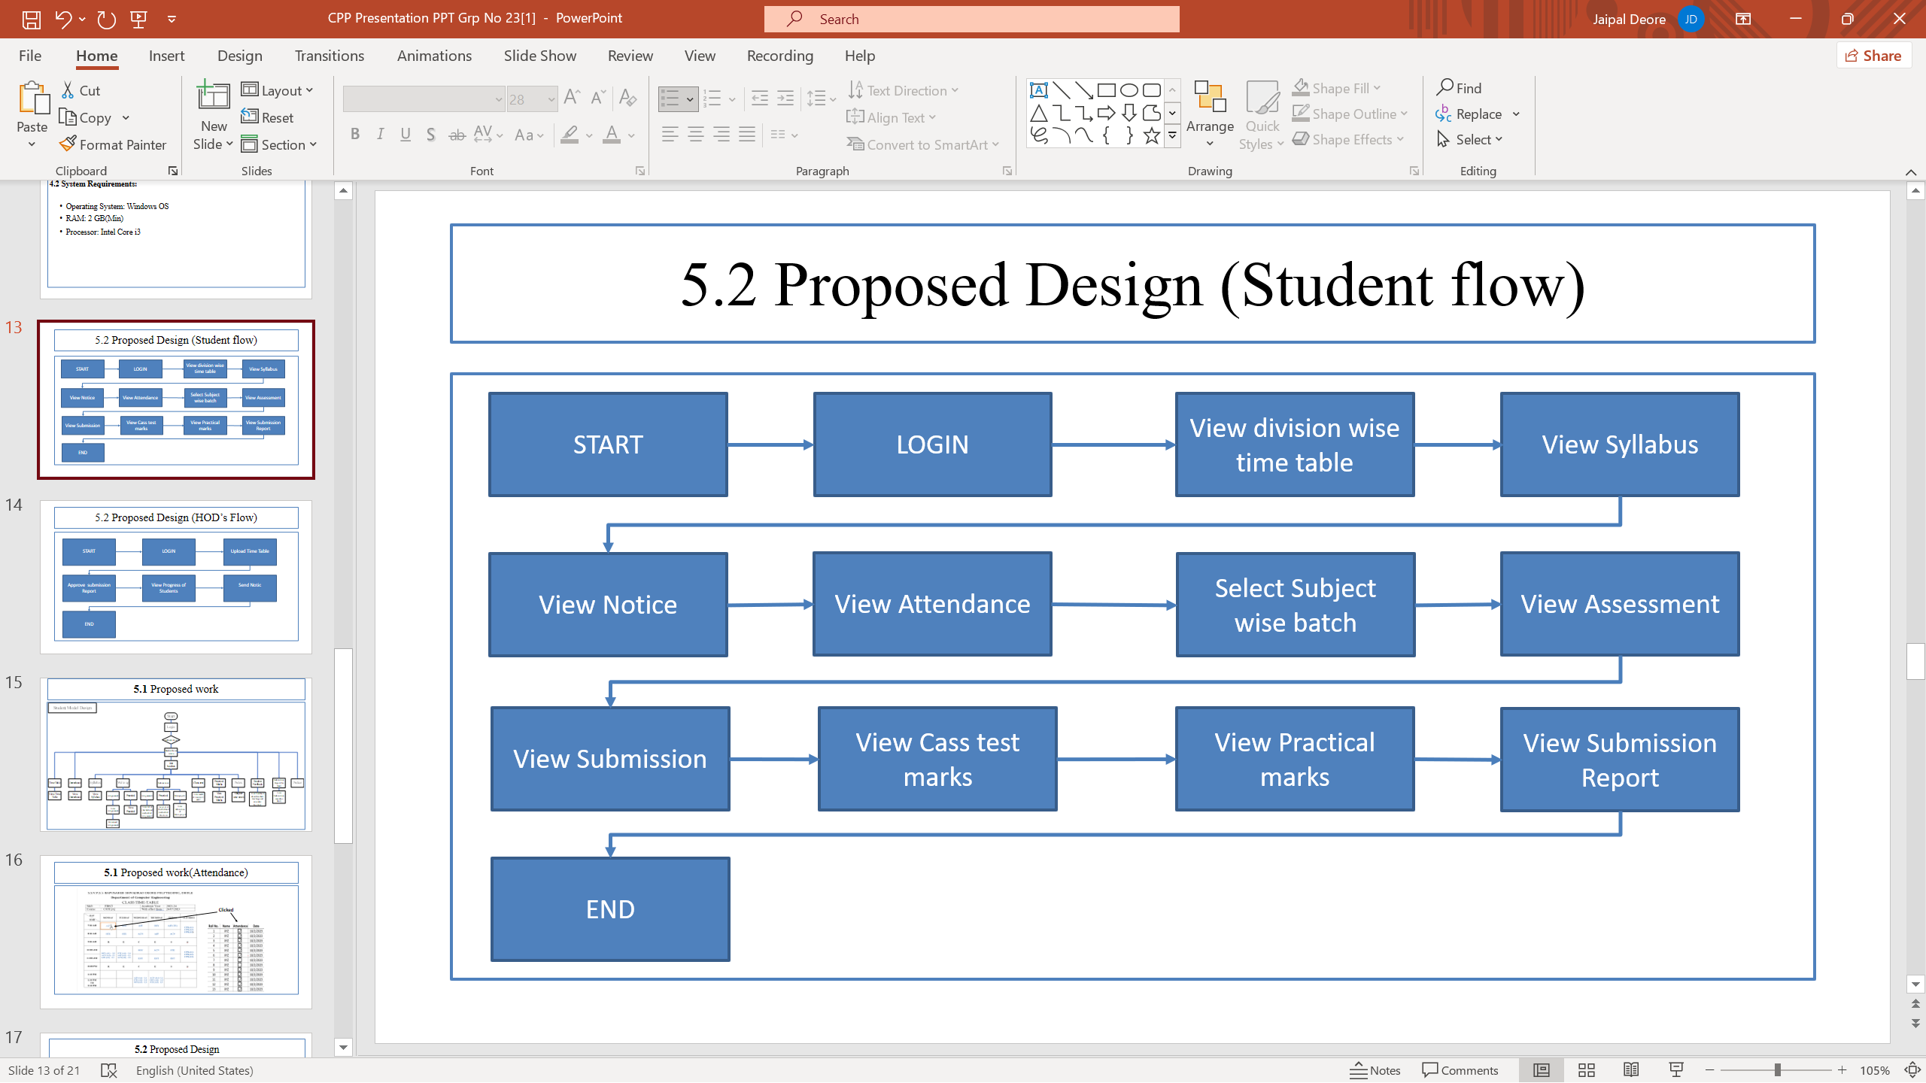

* 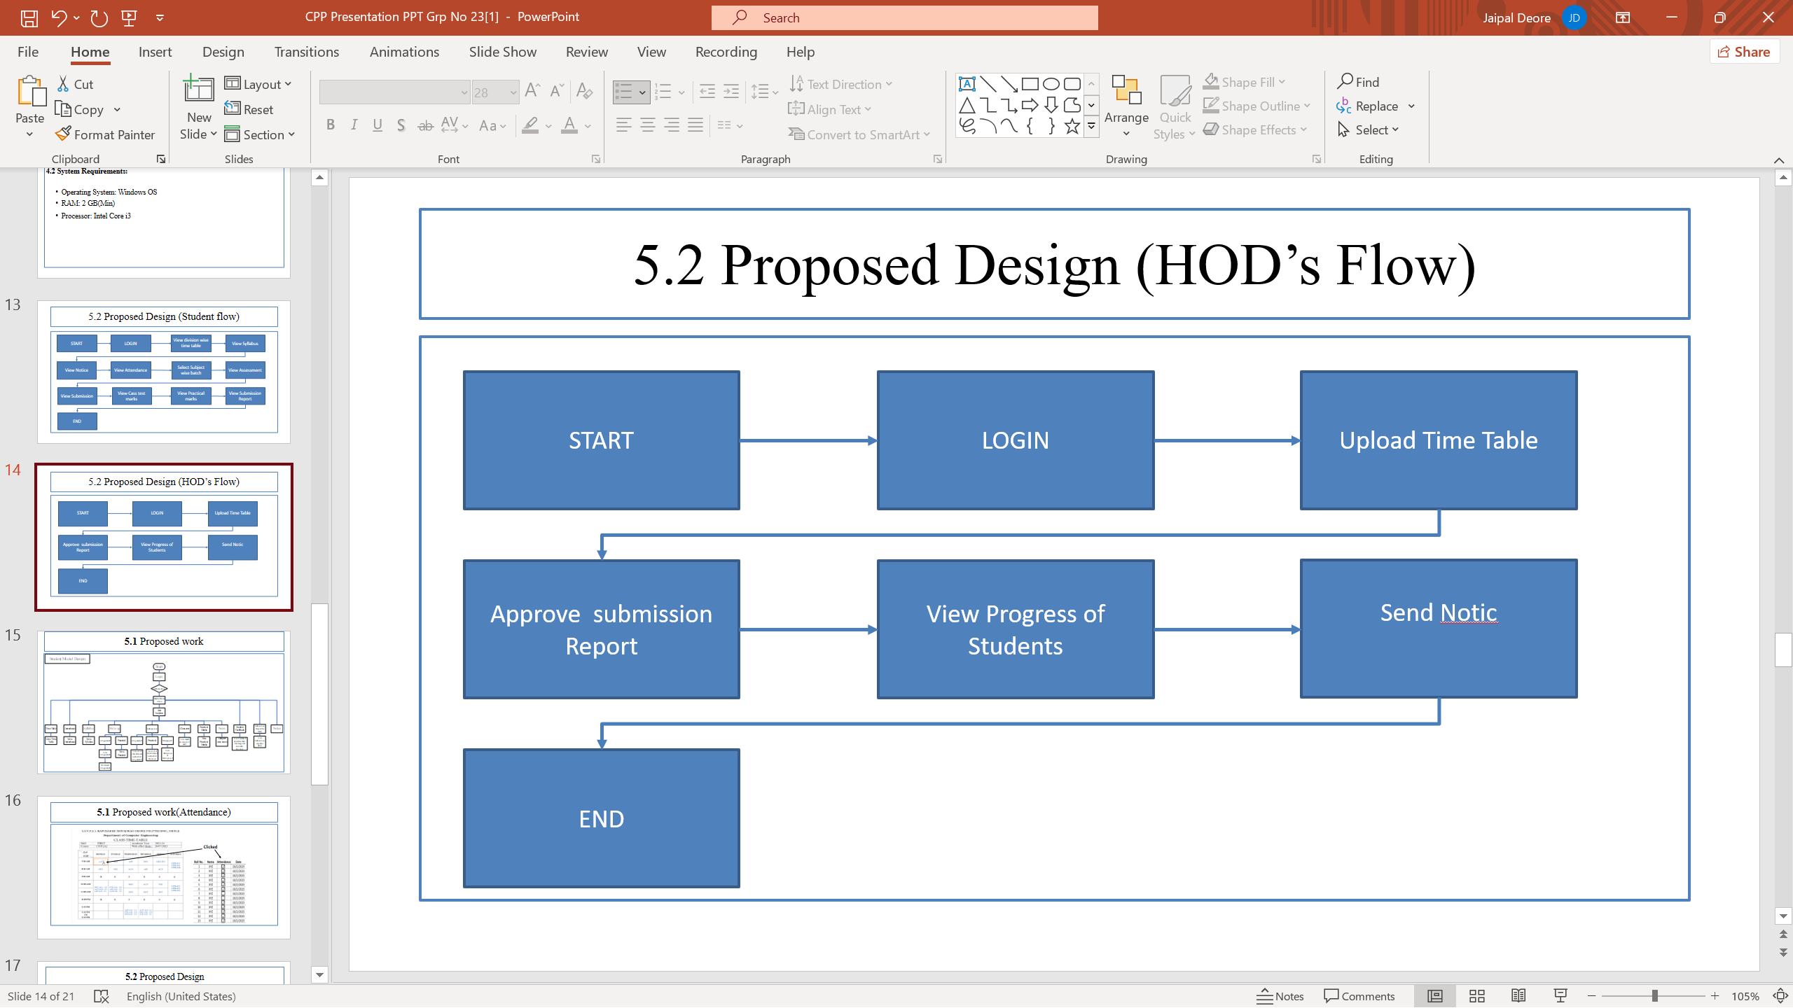**HOD’s Flow**
* **Attendance**

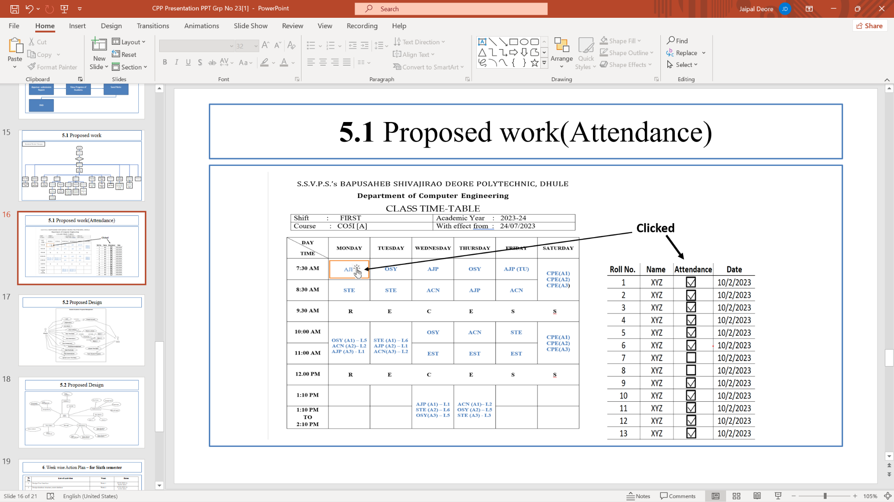

**4.2 Proposed design**

* 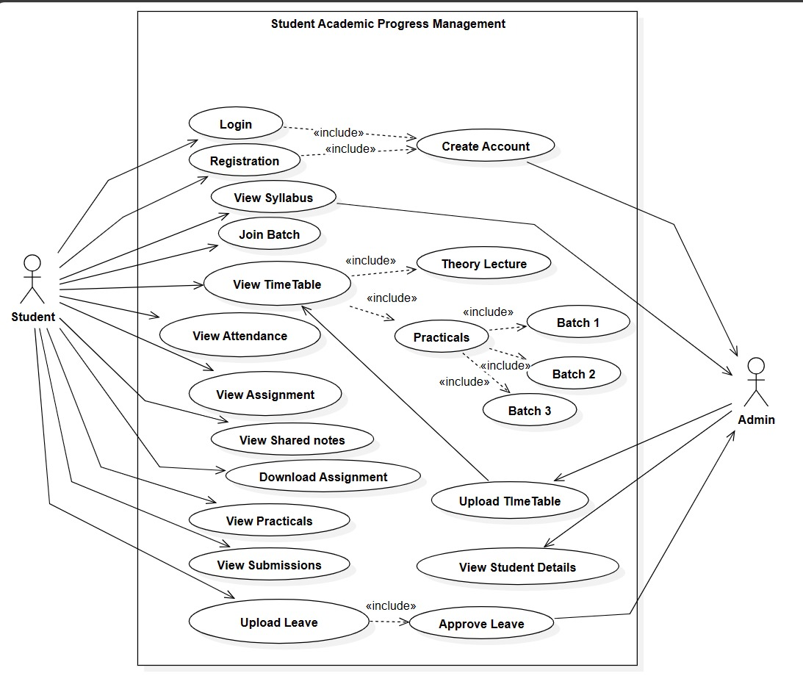**Use Case Diagram**
* **Entity Relationship Diagram**

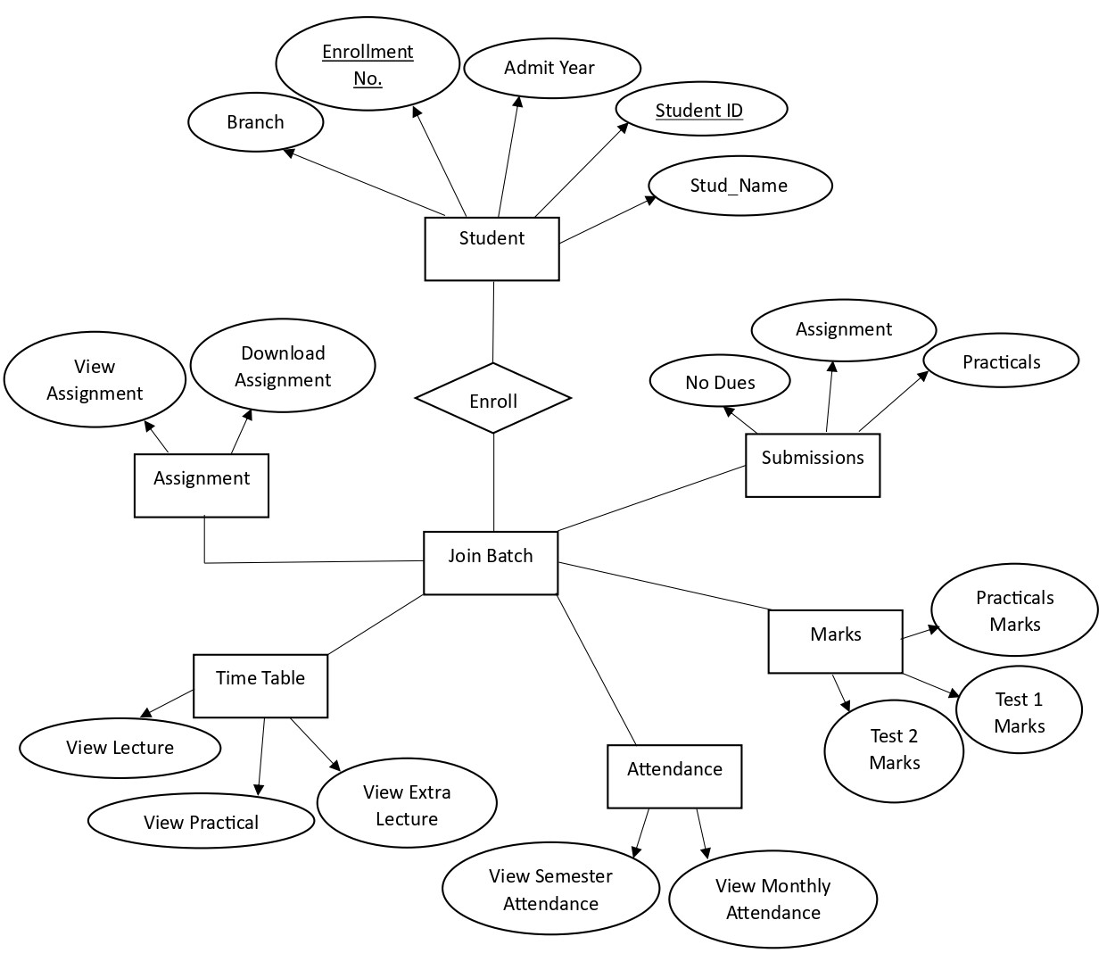

**Chapter No. 5**

**Week wise Action Plan for Sixth semester**

|  |  |  |  |
| --- | --- | --- | --- |
| **Sr. No.** | **List Of Activities** | **Week** | **Dates** |
| 1 | Design User Interface | Week 1 | 01/01/2024 to 06/01/2024 |
| 2 | Design database structure, create database | Week 2 | 07/01/2024 to 13/01/2024 |
| 3 | Develop GUI and various Interfaces | Week 3 | 14/01/2024 to 20/01/2024 |
| 4 | Programming / coding, database connectivity, if required | Week 4 | 21/01/2024 to 27/01/2024 |
| Week 5 | 28/01/2024 to 03/02/2024 |
| 5 | Installation of Project, Dummy Data Entry | Week 6 | 04/02/2024 to 10/02/2024 |
| 6 | Testing | Week 7 | 11/02/2024 to 17/02/2024 |
| 7 | Modifications (if any required) | Week 8 | 18/02/2024 to 24/02/2024 |
| 8 | Project Report Writing | Week 9 | 25/02/2024 to 02/03/2024 |
| 9 | Submission of project report | Week 10 | 03/03/2024 to 09/03/2024 |

**Chapter No. 6**

**References**

Student record management system:

<https://www.iitms.co.in/blog/student-record-management-system.html>

The Use of existing systems Student record management:

<https://www.google.com/amp/s/www.softwaresuggest.com/blog/student-record-management-system/amp/>

GitHub Repository:

<https://github.com/kishanrajput23/Student-Information-System>